Are We There Yet?
Summer is here, and vacation season is upon us! Airports are crowded, and airfares have increased, as have the prices of gas, hotel rooms, and restaurant bills. For those that are loading up the family and driving, how long will it take before those in the front seat hear from the back seat “are we there yet?” Personal experience reminds me that the more they ask, the more the anxiety level may rise, and the quicker even those in the front seat then want to get there.
How does this apply to the markets? The S&P500 Index is down -22% and the Barclays Aggregate Bond Index is down 11% ytd, and investors in both stocks and bonds are asking the same thing… “are we there yet?” Are we at or near a market bottom in stock and bond prices given the weakness that we’ve experienced this year? The more we wonder, the more we think about the uncertainties, the higher the anxiety level may rise, and the higher the hope becomes that the worst is behind us. This increased level of hope, however, can lead to more disappointment as we still wait to “get there”. To address the market trip that we’re on, let’s first look at what has happened to stocks, as represented by the S&P 500 Index, in the past after they’ve fallen 20% from their highs.
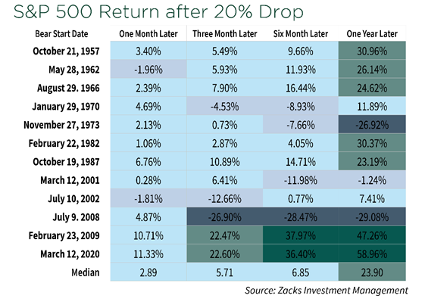
As you can see, there has been a wide range of potential return outcomes over various short-term time frames in the past following stock weakness similar to what we’ve experienced this year. Taking a longer-term view increases your chances of positive returns. While none of these periods had the same economic and earnings environments, the point is that stocks tend to recover over the long-term, and we expect that to be the case again this time. Why? Because, for now, earnings growth of approximately +8% is expected this year and next, and valuations have come back near historical averages (S&P 500 forward price/earnings = 16.2), providing a decent backdrop to invest in stocks. The biggest questions in our minds are how persistent will inflation be? and how much will it affect earnings expectations? To put it simply, if inflation peaks this year and rolls over, as the Fed (and all of us) hopes, we gain confidence in earnings expectations and believe stock prices would stabilize. If not, and earnings expectations decline, we could see more stock weakness until inflation does peak.
And what about bonds? Bond prices decline as interest rates rise, and the Fed’s goal of reducing inflation means interest rates, at least short-term rates, are expected to go higher. How high and how quickly? Again, it depends, in our minds, on future inflation numbers. If inflation peaks this year and rolls over, the chance of further interest rate increases is reduced, and bond prices could stabilize. If not, and interest rates continue to increase, bond prices could move lower.
Interestingly, while this is the worst bond market in 40+ years, since 1980, there have only been four years (1994, 1999, 2013, and 2021) when the Barclays US Aggregate Index posted losses. And each time, returns were positive the following year. This year may be different, but the main point is bonds have had positive annual returns 38 of the past 42 years in various interest rate environments year. Further, bond volatility is lower than equity volatility, and when interest rates peak and eventually decline, bond prices will reward investors.
With all of this in mind, remember that both the stock and bond markets do not wait for the Fed. Financial markets tend to discount what is expected in the future, so at least some of the inflation questions we’re facing is likely discounted in current prices. And importantly, consumer balance sheets, savings, and incomes are healthy. This bodes well for the future. Yes, there is near-term uncertainty, but we believe investors should take the long-term view when asking “are we there yet?” and focus more on the destination than on this leg of the trip.
As always, thank you for letting us help guide you toward your financial goals!

Sincerely,
Gary Orf CFA®

Zacks Investment Management, June 20, 2022.
Zacks Investment Management, June 17, 2022.
JPMorgan Asset Management, June 20, 2022.
JPMorgan Asset Management, March 31, 2022. The Barclays U.S. Aggregate Bond Index is a broad-based bond index comprised of government, corporate, mortgage and asset-backed issues, rated investment grade or higher, and having at least one year to maturity. The S&P 500 Index is an unmanaged index of 500 stocks that is generally representative of the performance of larger companies in the U.S. Please note an investor cannot invest directly in an index.​ This material represents an assessment of the market environment at a specific point in time and is not intended to be a forecast of future events, or a guarantee of future results. This information should not be relied upon by the reader as research or investment advice regarding any funds or stocks in particular, nor should it be construed as a recommendation to purchase or sell a security. Past performance is no guarantee of future results. Investments will fluctuate and when redeemed may be worth more or less than when originally invested. Gary Orf is a registered representative and investment advisor representative of Securian Financial Services, Inc. Securities and investment advisory services offered through Securian Financial Services, Inc. Member FINRA/SIPC. Renaissance Financial is independently owned and operated. 5700 Oakland Avenue, Suite 400 St. Louis, MO 63110 4800011 DOFU 06/2022

